Class 1: Spoken English & Fluency
Module 1: Naming Things in My Room (Speaking clearly about immediate objects)
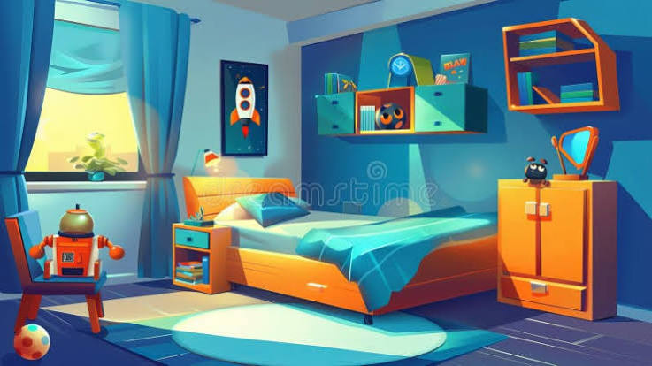
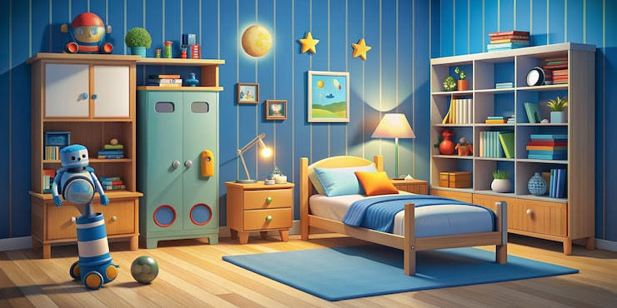
Step 1: The Listening & Speaking Story
Trainers should read this aloud. Encourage the child to look around the room and echo the bold words with clear, loud pronunciation.
Look! This is Adi's room.
Adi likes to play in his room. He stands up and points his finger. He says, "Look at my soft, blue bed." He jumps up and down. He likes his bed!
Next, Adi walks to the corner. He touches his wooden table. On top of the table is a little lamp. Flash! The lamp shines bright light.
Adi sits down on his green chair. He looks at his big box. What is inside the box? It is full of toys! He pulls out a shiny red car.
Adi smiles and says, "I love my room!"
Step 2: Spoken Comprehension Check
Ask the child these questions. Encourage them to answer verbally in full, simple phrases instead of just pointing or nodding.
- What color is Adi's bed? (Expected student voice: "It is blue!")
- What shines bright light on the table? (Expected student voice: "The lamp!")
- Where does Adi sit down? (Expected student voice: "On the chair!")
- What is inside the big box? (Expected student voice: "Toys!")
- Say "Yes" or "No": Is Adi sad in his room? (Expected student voice: "No!")
Step 3: Speech Focus & Word Shortcuts
Practice saying these primary object words together. Pay attention to the clear ending sounds of each word.
Target Objects Gallery
- Bed (Make a clean 'd' sound at the end: Be-d)
- Table (Pop the lips together for the 'b': Ta-ble)
- Chair (Pull the tongue back slightly for the 'r': Ch-air)
- Lamp (Close the lips firmly for the 'mp': La-mp)
- Box (Make a sharp 'ks' sound at the end: Bo-x)
- Toys (Add a buzzing 'z' sound for more than one toy: Toy-z)
Spoken Shortcuts (Contractions)
Teach the child to blend words together naturally, just like native speakers do when talking out loud:
- Instead of saying "What is this?" → Say: "What's this?"
- Instead of saying "It is a..." → Say: "It's a..."
- Instead of saying "I am..." → Say: "I'm..."
Step 4: Real-Life Spoken Conversations
Practice these dialogues with the child. Take turns playing the different roles to boost vocal confidence.
Conversation 1: Showing Your Room to a Friend
Adi: Welcome to my room! Come in!
Sam: Wow! Your room is so clean. What's this? (pointing near the wall)
Adi: It's a big, blue bed. Sit down!
Sam: Thank you! It is very soft. What is that on your table?
Adi: It's a funny lamp. Watch this! (turns it on)
Sam: Cool! It is very bright.
Conversation 2: Looking for a Missing Toy with Mom
Mom: Adi, it is time to clean up. Where is your red car?
Adi: I'm looking for it, Mom. It is not on my table.
Mom: Look under your chair. Is it there?
Adi: No, it isn't. What's this behind the curtain? Oh, it's a ball!
Mom: Check your big box of toys.
Adi: Ah! Found it! My car is inside the box.
Conversation 3: Getting Ready for Bed
Dad: Adi, time for sleep. Switch off the light, please.
Adi: Can I keep my little lamp on, Dad?
Dad: Okay, you can keep the lamp on. Put your storybook on the table.
Adi: Look, my teddy bear is already sleeping on the bed!
Dad: Haha, yes he is. Goodnight, Adi.
Adi: Goodnight, Dad!
Step 5: Live Vocal Activities
Activity 1: The "Tap and Name" Game
- How to play: The trainer or parent walks around the actual room with the child. Tap an object suddenly with a hand.
- The Challenge: The child must instantly speak using the spoken shortcut format: "It's a bed!" or "It's a chair!" Speed up the tapping to make it fun and silly!
Activity 2: The Sound Echo Drill
- How to play: Say the words with a clear vocal bounce to practice basic pronunciation.
- The Drill:
  - Trainer says: "La-mp" → Child echoes: "La-mp!"
  - Trainer says: "Bo-x" → Child echoes: "Bo-x!"
  - Trainer says: "Toy-z" → Child echoes: "Toy-z!"
Step 6: Picture Word Glossary
Help the child associate the spoken word with immediate, basic meanings.
- Room: A space inside a house with walls where you sleep or play.
- Bed: The soft piece of furniture where you lie down to sleep at night.
- Table: A flat surface with legs where you can keep your books, lamps, or food.
- Chair: Something with a backrest where you sit down safely.
- Lamp: A small device that gives you light when a room gets dark.
- Box: A square container used to hold or store things like shoes, clothes, or games.
- Toys: Fun items made for children to play with, like dolls, blocks, or toy cars.

